1. Write a C# Sharp program that takes three letters as input and display

them in reverse order.

Test Data  
Enter letter: b  
Enter letter: a  
Enter letter: t

Expected Output :  
t a b

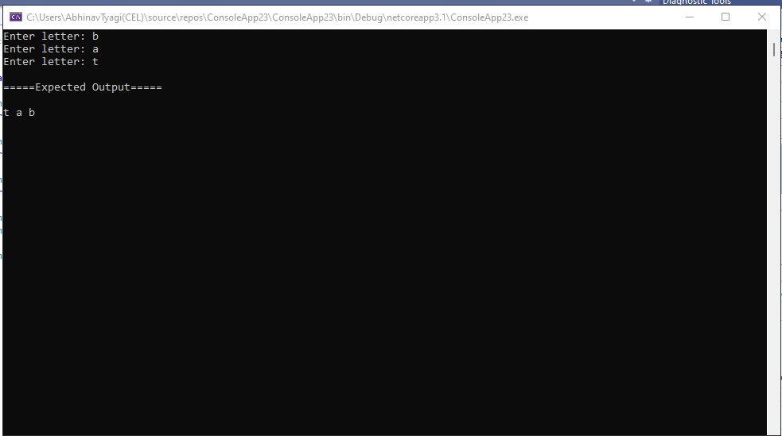

1. Write a C# Sharp program that takes a number and a width also a number, as input and then displays a triangle of that width, using that number.

Test Data  
Enter a number: 6  
Enter the desired width: 6

Expected Output*:*

666666

66666

6666

666

66

6

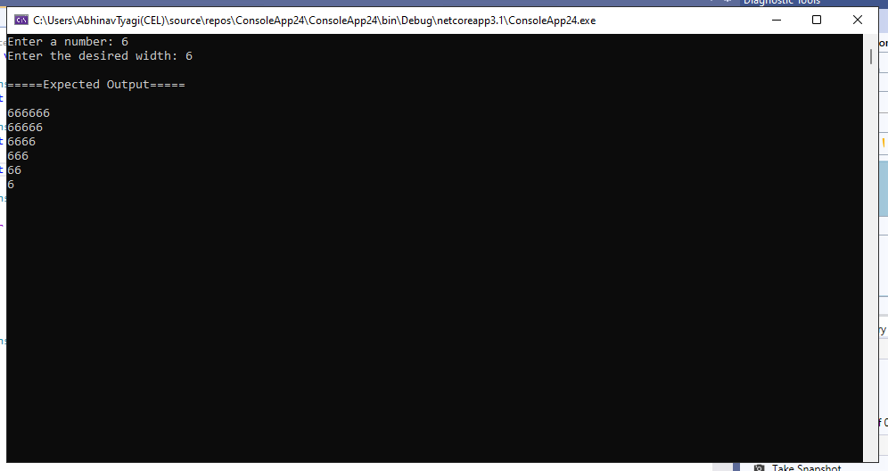

1. Write a C# Sharp program that takes userid and password as input (type string). After 3 wrong attempts, user will be rejected.(Store user data in hashtable/Dictionary)

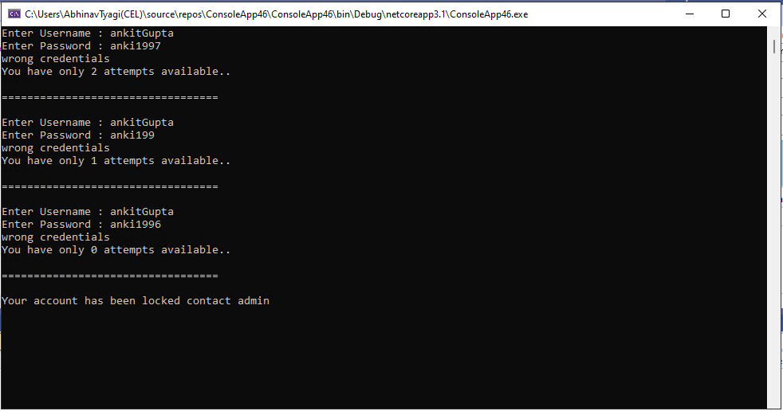

1. Write a C# Sharp program that takes two numbers as input and perform an operation (+,-,\*,x,/) on them and displays the result of that operation

Test Data  
Input first number: 20  
Input operation: -  
Input second number: 12

Expected Output :  
20 - 12 = 8

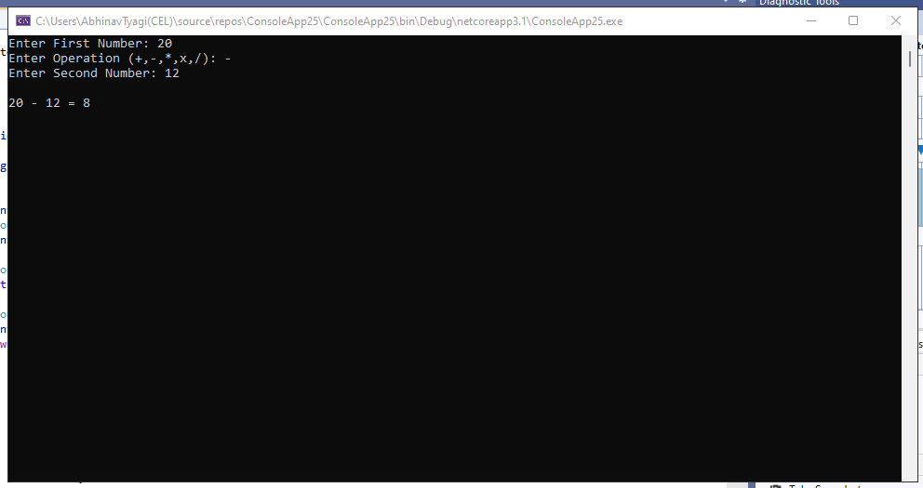

1. Write a C# Sharp program that takes the radius of a circle as input and calculate the perimeter and area of the circle.

Test Data  
Input the radius of the circle :  
12

Expected Output :  
Perimeter of Circle : 75.36

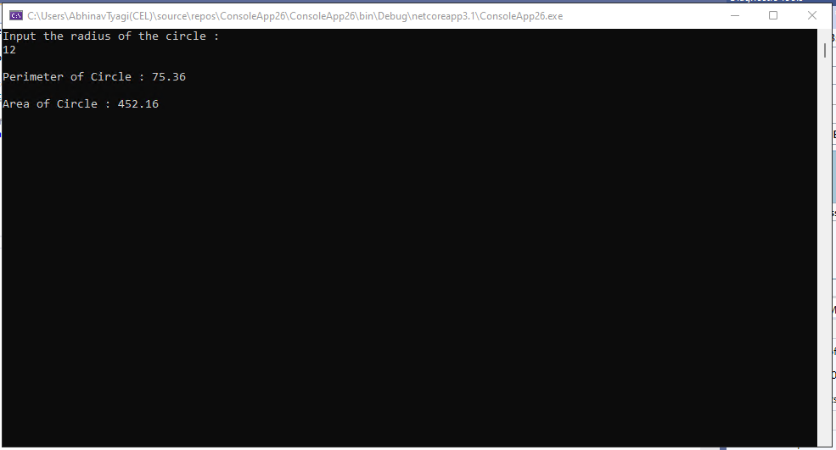

1. Write a C# Sharp program that takes distance and time as input and displays the speed in kilometres per hour and miles per hour.

Test Data:  
Input distance(metres): 50000  
Input timeSec(hour): 1  
Input timeSec(minutes): 35  
Input timeSec(seconds): 56

Expected Output:  
Your speed in metres/sec is 8.686588  
Your speed in km/h is 31.27172  
Your speed in miles/h is 19.4355

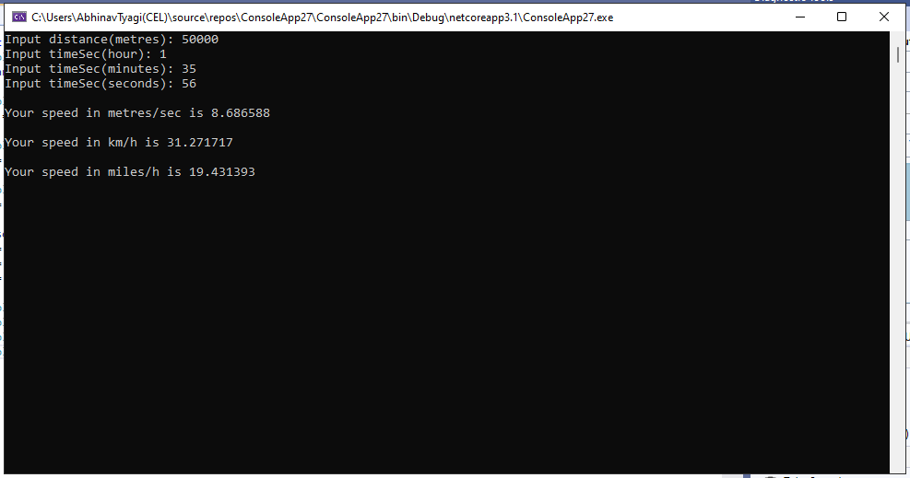

1. Write a C# Sharp program that takes a character as input and check the input (lowercase) is a vowel, a digit, or any other symbol.

Test Data:  
Input a symbol: a

Expected Output:  
It's a lowercase vowel.

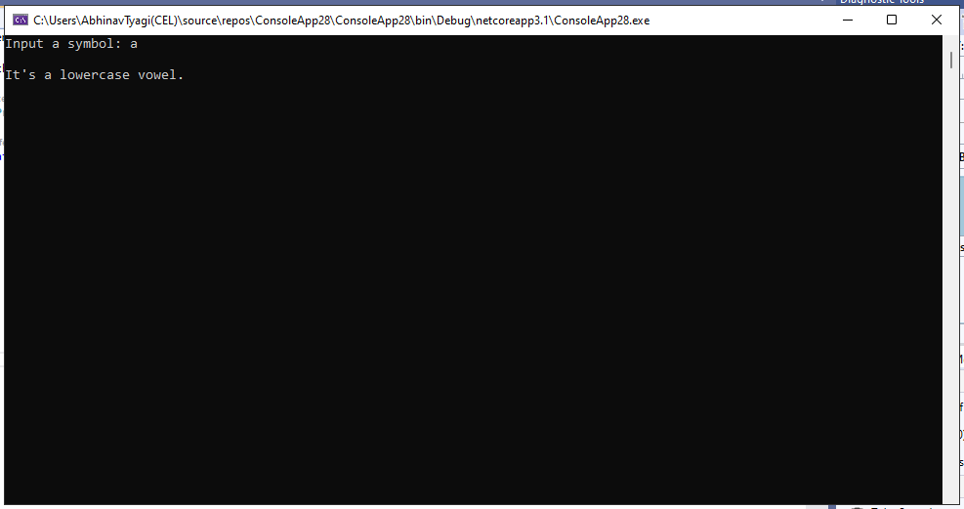

1. Write a C# Sharp program that takes two numbers as input and returns true or false when both numbers are even or odd.

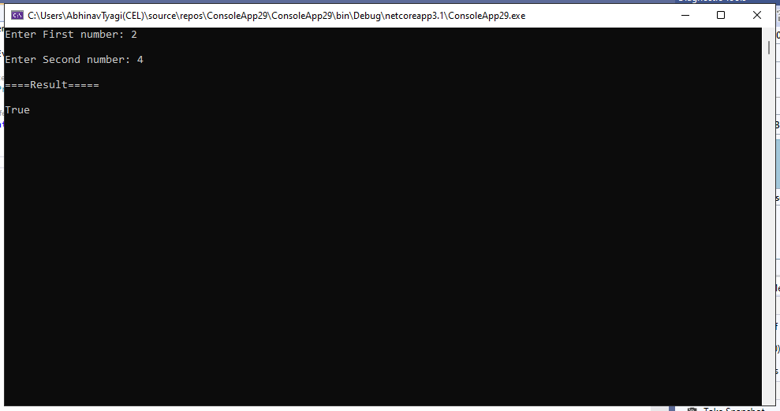

1. Write a C# Sharp program that takes a decimal number as input and displays its equivalent in binary form.

Test Data:  
Number to convert (or "end")? 25

Expected Output:  
Binary: 11001

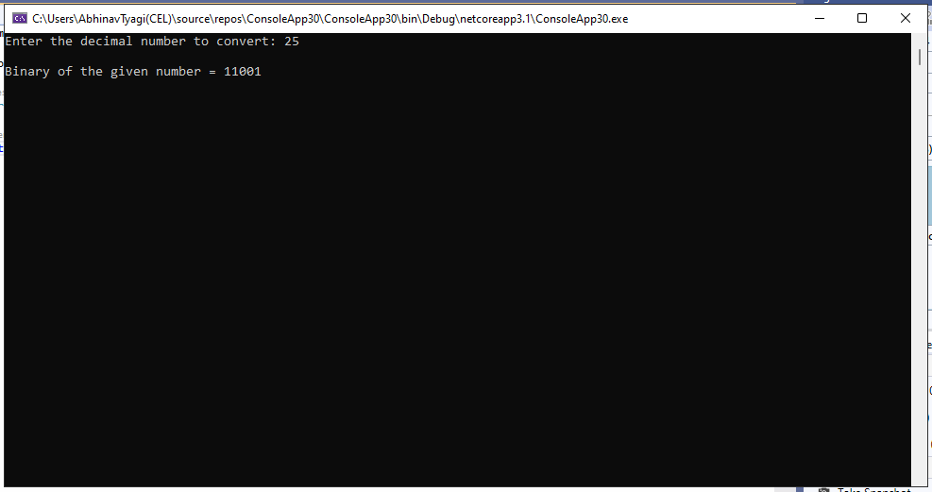

1. Write a C# Sharp program to get the absolute difference between n and 51. If n is greater than 51 return triple the absolute difference.

Sample Input:  
53  
30  
51  
Expected Output:

6

21

0

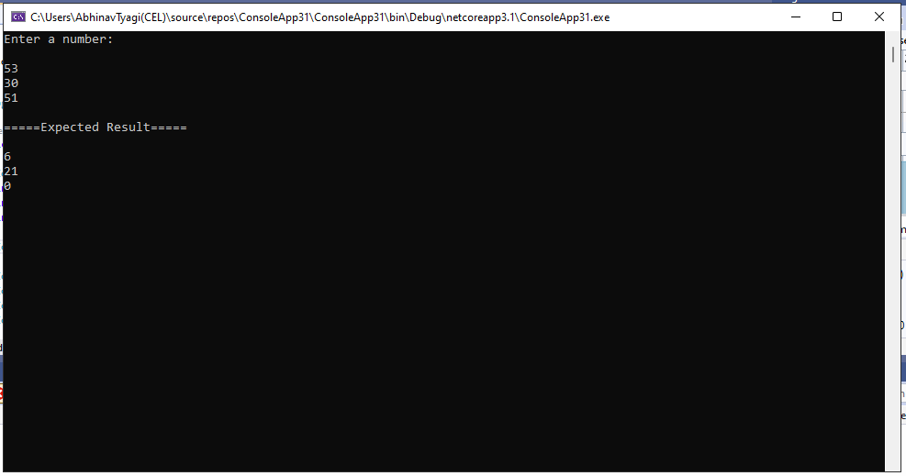

1. Write a C# Sharp program to remove the character in a given position of a given string. The given position will be in the range 0.. string length -1 inclusive.

Sample Input:  
"Python", 1  
"Python", o  
"Python", 4

Expected Output:

Pthon

ython

Pythn

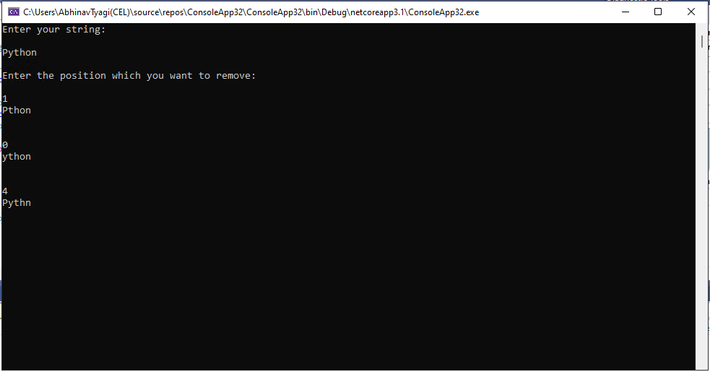

1. Write a C# Sharp program to exchange the first and last characters in a given string and return the new string.

Sample Input:  
"abcd"  
"a"  
"xy"

Expected Output:

dbca

a

yx

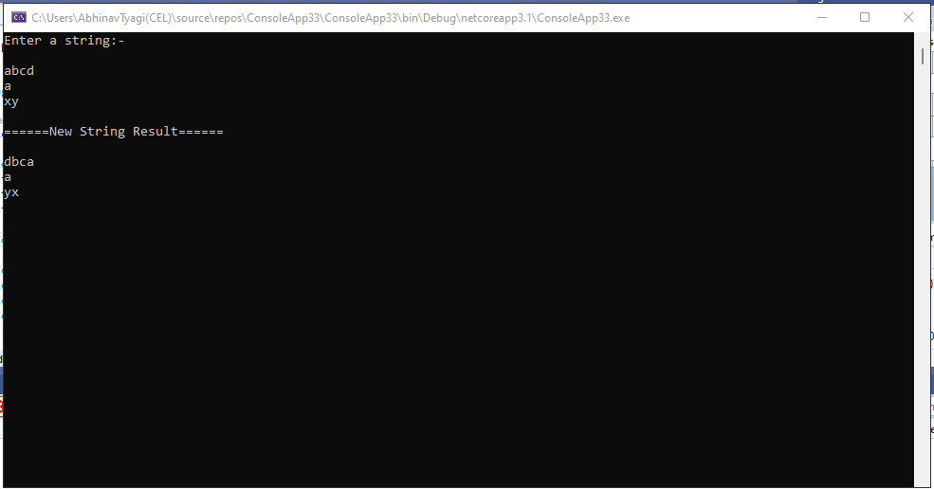

1. Write a C# Sharp program to create a new array from two give array of integers, each length 3

Sample Input:  
{ 10, 20, 30 }, { 40, 50, 60 }

Expected Output :

Array 1: 10, 20, 30

Array 2: 40, 50, 60

New array: 10 20 30 40 50 60

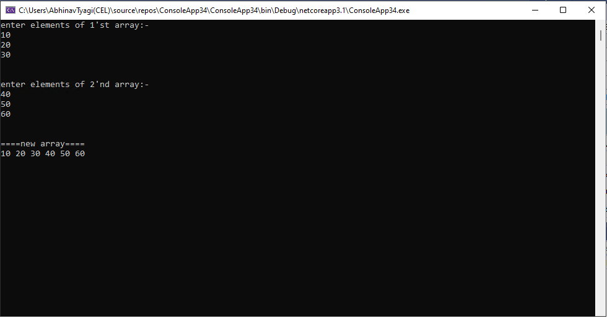

1. Write a C# Sharp program to count the number of strings with given length in given array of strings

Sample Input:  
{"a", "b", "bb", "c", "ccc" }, 1

Expected Output:

Number of Strings:

3

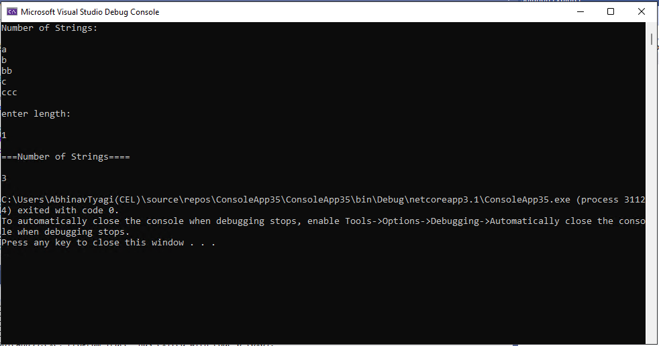

1. Write a C# Sharp program to calculate the value that results from raising 3 to a power ranging from 0 to 32

3^0 = 1 (0x1)  
3^1 = 3 (0x3)  
3^2 = 9 (0x9)  
3^3 = 27 (0x1B)  
3^4 = 81 (0x51)  
3^5 = 243 (0xF3)  
3^6 = 729 (0x2D9)  
3^7 = 2,187 (0x88B)  
3^8 = 6,561 (0x19A1)  
3^9 = 19,683 (0x4CE3)  
3^10 = 59,049 (0xE6A9)  
3^11 = 177,147 (0x2B3FB)  
3^12 = 531,441 (0x81BF1)  
3^13 = 1,594,323 (0x1853D3)  
3^14 = 4,782,969 (0x48FB79)  
3^15 = 14,348,907 (0xDAF26B)  
3^16 = 43,046,721 (0x290D741)  
3^17 = 129,140,163 (0x7B285C3)  
3^18 = 387,420,489 (0x17179149)  
3^19 = 1,162,261,467 (0x4546B3DB)  
3^20 = 3,486,784,401 (0xCFD41B91)  
3^21 = 10,460,353,203 (0x26F7C52B3)  
3^22 = 31,381,059,609 (0x74E74F819)  
3^23 = 94,143,178,827 (0x15EB5EE84B)  
3^24 = 282,429,536,481 (0x41C21CB8E1)  
3^25 = 847,288,609,443 (0xC546562AA3)  
3^26 = 2,541,865,828,329 (0x24FD3027FE9)  
3^27 = 7,625,597,484,987 (0x6EF79077FBB)  
3^28 = 22,876,792,454,961 (0x14CE6B167F31)  
3^29 = 68,630,377,364,883 (0x3E6B41437D93)  
3^30 = 205,891,132,094,649 (0xBB41C3CA78B9)  
3^31 = 617,673,396,283,947 (0x231C54B5F6A2B)  
3^32 = 1,853,020,188,851,841 (0x6954FE21E3E81)

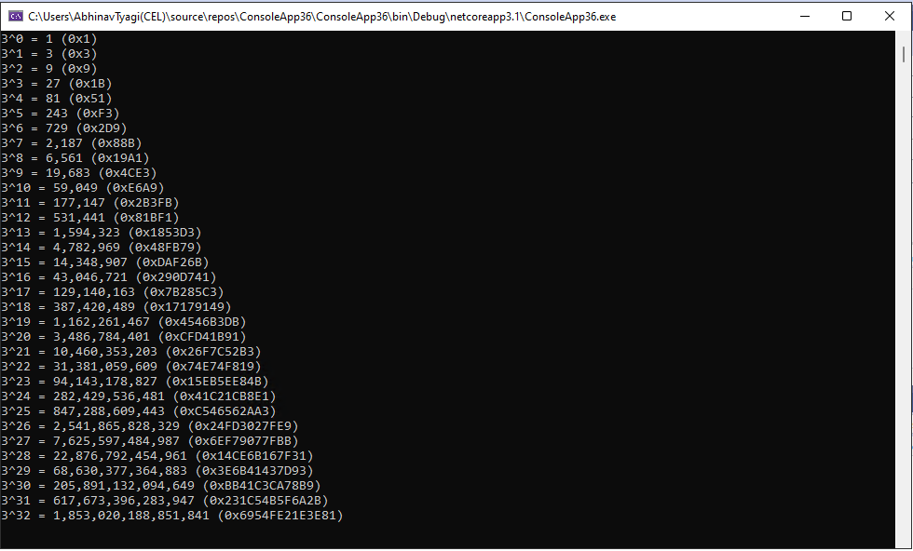

1. Write a C# Sharp program to convert a given integer value to Roman numerals

Expected Output:  
Original integer value: 2365  
Roman numerals of the said integer value:  
MMCCCLXV  
Original integer value: 254  
Roman numerals of the said integer value:  
CCLIV  
Original integer value: 45  
Roman numerals of the said integer value:  
XLV  
Original integer value: 8  
Roman numerals of the said integer value:  
VIII

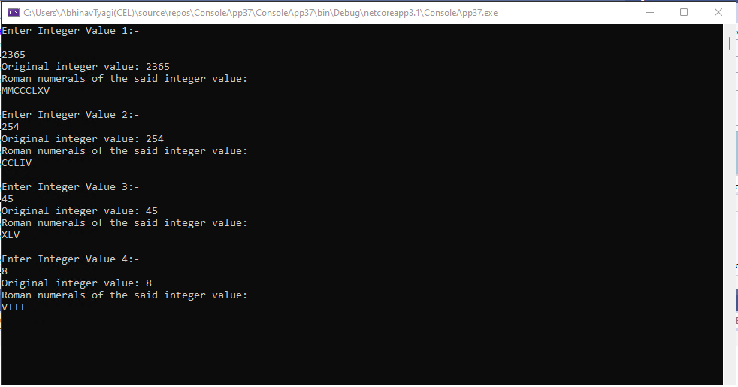

1. Write a program in C# Sharp to find the sum of first n natural numbers using recursion.

Test Data :How many numbers to sum : 10Expected Output :  
The sum of first 10 natural numbers is : 55

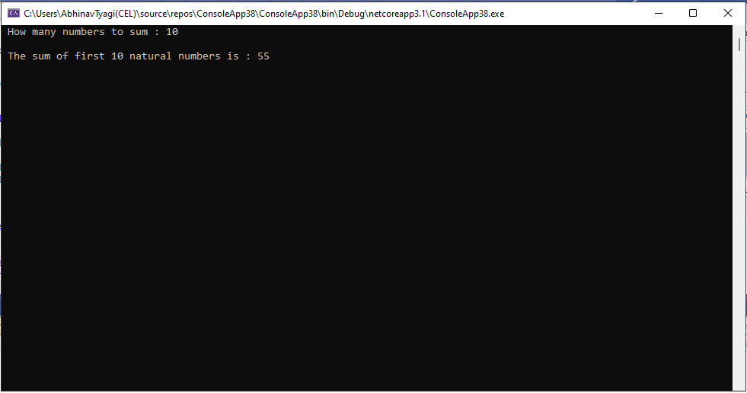

1. Write a program in C# Sharp to display the individual digits of a given number using recursion

Test Data :Input any number : 1234Expected Output :  
The digits in the number 1234 are : 1 2 3 4

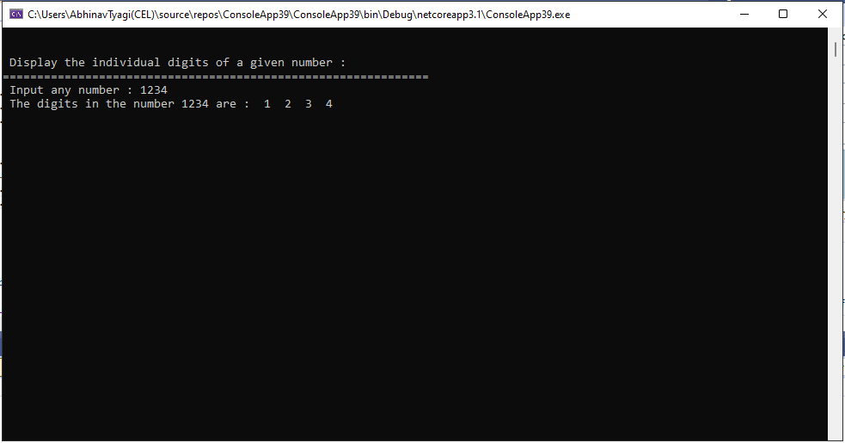

1. Write a program in C# Sharp to find the number of an array and the square of each number using LINQ

Expected Output :  
{ Number = 9, SqrNo = 81 }  
{ Number = 8, SqrNo = 64 }  
{ Number = 6, SqrNo = 36 }  
{ Number = 5, SqrNo = 25 }

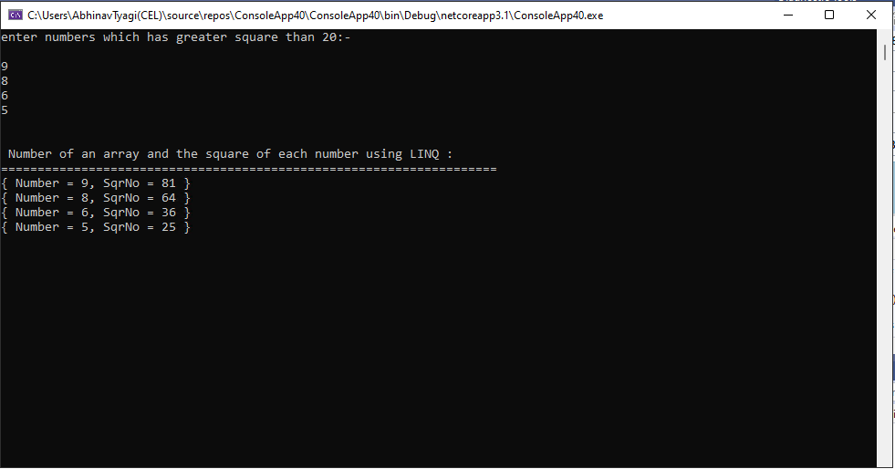

1. Write a program in C# Sharp to display the characters and frequency of character from giving string using LINQ

Test Data:  
Input the string: apple

Expected Output:  
The frequency of the characters are :  
Character a: 1 times  
Character p: 2 times  
Character l: 1 times  
Character e: 1 times

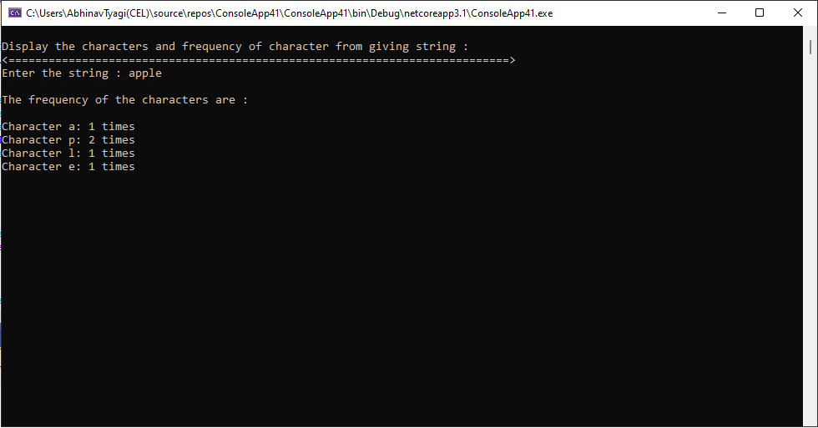

1. Write a program in C# Sharp to find the string which starts and ends with a specific character using LINQ

Test Data :  
The cities are : 'ROME','LONDON','NAIROBI','CALIFORNIA','ZURICH','NEW DELHI','AMSTERDAM','ABU DHABI','PARIS'  
Input starting character for the string : A  
Input ending character for the string : M  
Expected Output :  
The city starting with A and ending with M is : AMSTERDAM

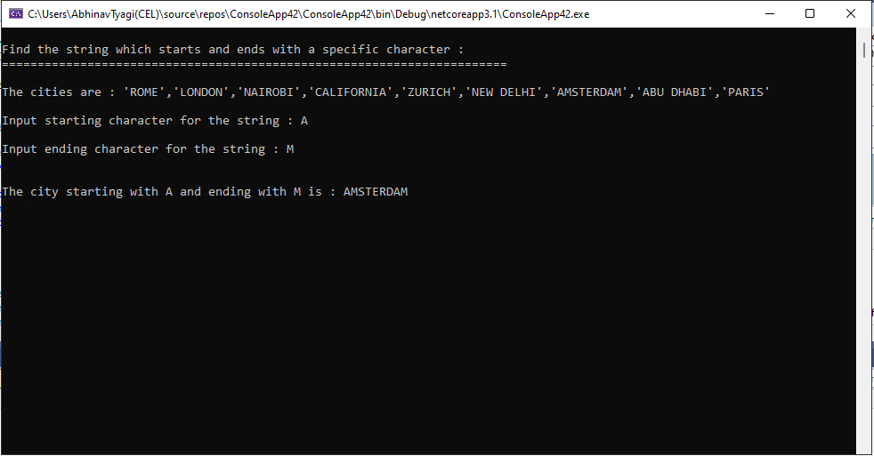

1. Write a program in C# Sharp to display the top n-th records using LINQ

Test Data :  
The members of the list are :  
5  
7  
13  
24  
6  
9  
8  
7  
How many records you want to display ? : 3  
Expected Output :  
The top 3 records from the list are :  
24  
13  
9

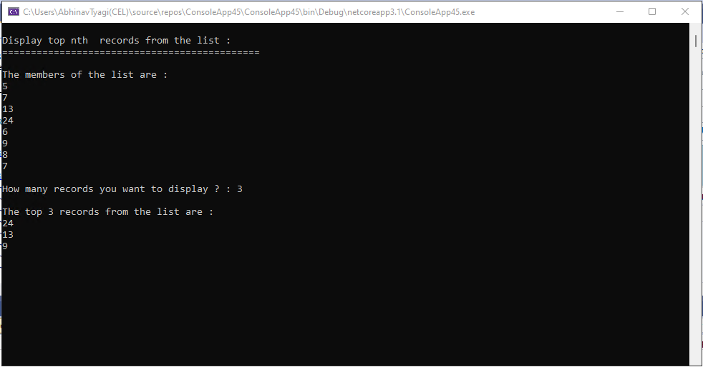

1. Write a program in C# Sharp to count file extensions and group it using LINQ

Test Data :  
The files are : aaa.frx, bbb.TXT, xyz.dbf,abc.pdf  
aaaa.PDF,xyz.frt, abc.xml, ccc.txt, zzz.txt  
Expected Output :  
Here is the group of extension of the files :  
1 File(s) with .frx Extension  
3 File(s) with .txt Extension  
1 File(s) with .dbf Extension  
2 File(s) with .pdf Extension  
1 File(s) with .frt Extension  
1 File(s) with .xml Extension

